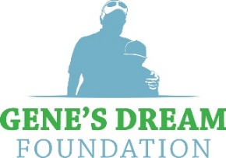

Presents the 2023 Mentor Cup and Dream Challenge Experiences

MISSION
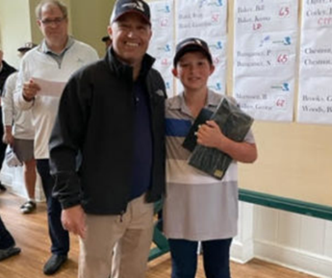
Having a strong mentor leads to success. Whether it is through guidance, education, confidence-building or access, every child deserves a chance to benefit from the riches of positive leadership.
Gene’s Dream Foundation and its prized tournament experiences, the Mentor Cup and Dream Challenge, are events tailored to identify and educate mentors and mentees across the nation, as well as raise critical funds through fun-filled tournaments with a focus on competition and camaraderie.

THE FOUNDATION
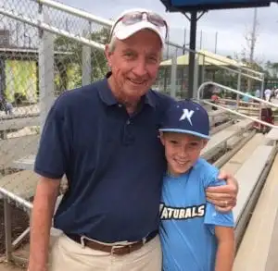
Gene’s Dream Foundation is a non-profit 501(c)(3) organization established in April of 2017 in honor of its namesake, Gene Weldon who lost his life to cancer in 2017. Weldon, a 44-year golf professional who was posthumously inducted into the Myrtle Beach Golf Hall of Fame for his dedication and efforts in growing the junior game along the Grand Strand, was also instrumental in fundraising efforts for the local TFT chapter in the Coastal Carolinas. His dream was to have his family and closest friends continue his efforts to ensure the health of the local chapter and junior golf programs in South Carolina and beyond. Weldon believed that golf was more than a game, it was a vehicle for connecting people and giving back to communities. One of his mentees, former professional golfer and TV broadcaster Kelly Tilghman along with Weldon’s close friend Joe White created the foundation to keep Gene’s Dream alive. https://genesdream.com/board-members/

EVENT ELIGIBILITY CRITERIA
MENTOR CUP MENTEES: Children between the ages of 7-18 years old who participate in The First Tee (TFT) program across the nation are permitted to participate in the Mentor Cup and its related activities.
MENTOR CUP MENTORS: Adults who are willing to lend support to the children through leadership, guidance, education and/or financial aid. Any adult who is not the parent of the mentee must be Safe Sport compliant in order to participate in all Mentor Cup related activities.
DREAM CHALLENGE PARTICIPANTS: Adults and children of all ages with a USGA handicap. If a handicap is not established, golfer will be assigned one following assessment by tournament committee.

MENTOR CUP
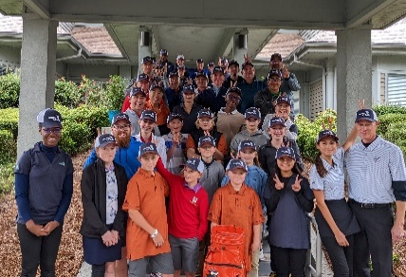
Newly added as part of The First Tee’s global trustee program, the Mentor Cup experience is the centerpiece of a weekend filled with bonding activities for all participating mentors and mentees.
Held annually at famed Tidewater Golf Club in North Myrtle Beach, SC on the last Saturday of October, it features a novice golf division with two-person teams comprised of mentors and mentees who compete in a 9-hole, fun-format filled with team building activities and collaborative contests. It also features a traditional player division in which the more experienced tandems compete in an 18-hole tournament with awards going to the teams with the lowest scores.
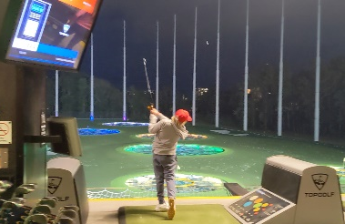
ENTERTAINMENT: Each year, the Mentor Cup weekend features entertainment in various forms. Participants are treated to an evening of fun ahead of the tournament that includes family friendly activities for children and adults. Events include concerts, gala dinners and action-packed nights in one of the many entertainment venues the greater Myrtle Beach area has to offer (e.g., TopGolf, miniature golf courses, theatres, etc.).
EDUCATION: Gene’s Dream Foundation provides several ancillary events open for individual or corporate sponsorship that support its mission and the Mentor Cup experience. As part of our highly acclaimed package, we offer clinics with professional athletes, panel discussions, Q&A sessions with influential personalities (professional athletes, stage/screen personalities & leading businessmen and women). These events are geared toward teaching adults and children how to better communicate to achieve success.

DREAM CHALLENGE
Each year, Gene’s Dream Foundation stages an action-packed 18-hole scramble tournament loaded with luxurious gifts and prizes. Serving as one of the primary fundraising arms for the foundation, this tournament welcomes golfers from across the Carolinas region to compete for golf bags, clubs, high tech equipment, clothing, luggage, gift cards and more. It also offers an exclusive invitation to compete in the 2024 Applied Underwriters Invitational at Big Cedar Lodge in Ridgedale, Missouri.
This year’s Dream Challenge will be held at beautiful Shaftesbury Golf and Fish Club in Conway, SC. Entry fees are $800 per foursome. Participating golfers will receive registration prizes valued at more than $400 per player including duffel bags, shirts, hats, Bridgestone golf balls, golf cart phone caddies, cooling sleeves and more. Prizes are awarded for the top 6 placing teams, longest drive, and closest to the pin. There are also raffle and silent auction items available for bidding, including an autographed 2019 Tiger Woods Masters flag and behind-the-scenes experiences at the 2024 Wells Fargo Invitational.

HOW TO BECOME A SPONSOR
There are multiple ways to become a supportive member of our mission. We are a not-for-profit organization, so every dollar raised is put directly toward the growth of youth area programs like The First Tee of Coastal Carolinas and many more. Both the Dream Challenge and various aspects of the Mentor Cup experience are eligible for sponsorship. The following is a list of ways you can become involved. Thank you for your consideration and the opportunity to keep Gene’s Dream alive!
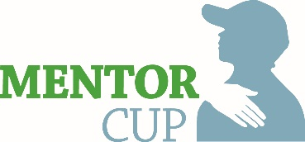
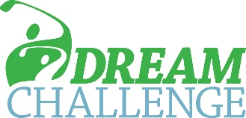
Sponsorship Opportunities

$50,000 Exclusive Sponsor
Sole sponsor for both Mentor Cup and Dream Challenge – No competing sponsors
$7,500 Shirt and Cap packages for both tournaments
24 seats at pre-tournament event – Night at Top Golf
6 Foursomes at Dream Challenge and 8 Mentor/Mentee groups at Mentor Cup
Recognition on foundation/tournament websites

$25,000 Event Sponsor
Sole sponsor for celebrity entertainment event or one of the two tournaments
$7,500 Shirt and Cap package for event or one tournament
12 seats at pre-tournament event – Night at Top Golf
4 Foursomes at Dream Challenge
Recognition on foundation/tournament websites

$15,000 Pre-Tournament Sponsor
Lead sponsor and 8 seats at pre-tournament event - Night at Top Golf
$7,500 Shirt and Cap package for event or one tournament
3 Foursomes at Dream Challenge
Recognition on foundation/tournament websites

$10,000 Presenting Sponsor
Banner at check-in area & tee/green signage – both tournaments
4 seats at pre-tournament event – Night at Top Golf
2 Foursomes at Dream Challenge
Recognition on foundation/tournament websites

$10,000 Shoe Package – Mentor Cup or Dream Challenge
Put a pair of Puma golf shoes on each player + 6 pair keepsake shoes with celebrity signatures
2 seats at pre-tournament event – Night at Top Golf
Prominent Announcement Banner at Tournament
Recognition on foundation/tournament websites

$7,500 Co-Branded Shirt Package – Mentor Cup or Dream Challenge
Donor Company/Gene’s Dream Logoed Shirts for players, volunteers + 12 keepsake shirts
2 seats at pre-tournament event – Night at Top Golf
Recognition on foundation/tournament websites

$7,500 Co-Branded Cap Package – Mentor Cup or Dream Challenge
Donor Company/Gene’s Dream Logoed Caps for players, volunteers + 12 keepsake caps
2 seats at pre-tournament event – Night at Top Golf
Recognition on foundation/tournament websites

$5,000 Green Sponsor – Mentor Cup or Dream Challenge
Commemorative Hole Flag signed by Nancy Lopez and Kelly Tilghman
Hole sign on 1 & 10 tee
2 seats at pre-tournament event – Night at Top Golf
Recognition on foundation/tournament websites

$3,500 Meal Sponsor – Mentor Cup or Dream Challenge
‘Meals Brought to You By’ signage at all meal sites
2 seats at pre-tournament event – Night at Top Golf
Recognition on foundation/tournament websites

$2,500 Cart Sponsor – Mentor Cup or Dream Challenge
‘Your Ride Brought to You By’ signage on all carts
Recognition on foundation/tournament websites

$1,500 Driving Range Sponsor – Mentor Cup or Dream Challenge
Sign on Driving Range

$1,000 Putting Green Sponsor – Mentor Cup or Dream Challenge
Sign on Putting Green

$1,000 Hole Flag Sponsor – Mentor Cup or Dream Challenge
Event Logo on Individual Hole Flag - Keepsake after event

$1,000 Upper Deck Plank Owner / Team Sponsor
Signed celebrity photo, Certificate in attractive frame and Designation on website
Limited time – One foursome in the Dream Challenge

$500 Plank Owner
Signed celebrity photo, Certificate in folio and Designation on website

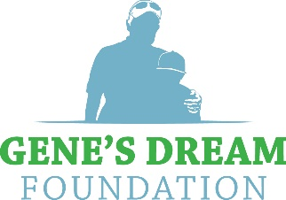

www.genesdream.com

